A Lightweight Stylometry+CodeBERTa Baseline for Software Vulnerability Detection (CPU vs GPU)
Author: Ajmal Abbas, Vishnu selvaraj
Guide: Gokhan Kul
Affiliation: University of Massachusetts Dartmouth

ABSTRACT
We present an end-to-end software vulnerability detection pipeline that fuses lightweight AST stylometry with transformer embedding to classify vulnerable functions across three popular datasets (devign, MVD,ReVeal). Concretely, we extract five structural style cues from python’s AST (counts of If, For, while, Try FunctionDef) and concatenate them with batched CodeBERT embeddings (max length 128), then train an MLP classifier. To support practical use, we add(i) unified dataset loading with automatic column detection, (ii) GPU/CPU-aware batched encoding, (iii) feature caching to.npz, and (iv) timing visualization via clean Gantt charts comparing CPU vs CUDA stages and cached-feature training. This design is aligned with stylometry -guided vulnerability detection in the vulstyle line of work (Secure-from-Inception: Software Security via Proactive Vulnerabilities Handling, chapter 6), where multi-perspective code representations improve robustness by capturing both stylistic and semantic signals. Result is reported with classification report 70/15/15 split, demonstrating a simple, reproducible baseline that runs on commodity hardware while benefiting from GPU acceleration for embedding. Related foundations in code stylometry and multimodal vulnerability detection motivate our feature choices.

INTRODUCTION
Accurate, scalable vulnerability detection remains a central challenge in secure software engineering. Purely semantic models (e.g code LMs) excel at capturing token-level patterns but can overlook how developers structure code information long exploited by stylometry to characterize authorial style and by extension, habitual coding practices that often correlate with vulnerable patterns. Building on this premise and inspired by the vulstyle framework’s emphasis on combining structural style with learned representations, we propose a compact pipeline that joins (1) AST- based style features with (2) transformers embeddings to classify vulnerable functions. The approach aims to be easy to reproduce, fast to iterate on and hardware-aware.

Method Overview:
Our loader unifies Devign/MVD/Reveal by detecting code/label columns at runtime; we then compute five AST stylometry counts per function and obtain CodeBERT-small-v1 embedding using batched tokenization on CPU or CUDA. Features are concatenated and passed to an MLP(1024,64) with an 70/15/15 train-test-split performance is summarized via classification_report. To assess practically, we cache features to. npz flor instant re training and generate Gantt charts contrasting CPU vs GPU timelines (AST,encoding , training) and cache -only training timeline.
Contributions:
- Unified multi-dataset baseline that pairs AST stylometry with transformers embeddings for vulnerability detection.
- Practical engineering: batched CUDS/CPU encoding, robust column detection, feature caching and reproducible timing visualizations.
- Hardware-aware analysis using Gantt charts to expose end-to end bottlenecks and the benefits of GPU acceleration.
- Stylometry -guided design consistent with prior evidence that combing structural style with semantics improves code forensics and related classification tasks.
Positing in literature, Stylometry has a long history in authorship and has been adapted to a source code, where structural /formatting choices and control -flow motifs provide distinctive signals that complement lexical semantics. Recent multimodal and LLM based efforts for vulnerability detection likewise supports leveraging multiple code views (text/graphs /image/features). Our pipeline operationalized this idea with minimal reproducible recipes suitable for rapid experimentation and extension.

Review Literature

In this research works we go through some research papers and also, we did take the ideas from them. The [1] The goal of Vulstyle, a multimodal pretraining framework that combines code stylometry features (lexical, syntactic) with deep learning representation for software vulnerability detection. The methodology of this work is developed a multi-model pipeline that integrates code stylometry feature extraction (non-terminal nodes from AST, syntactic & lexical features). Achieved state of the art accuracy with less input data and lower latency outperforming existing detectors. Extend to multi language vulnerability detection, enhance generalization and integrate into real time CI/CD pipelines. This [2] paper is all about Improve vulnerability detection by learning comprehensive program semantics from real- world using GNNs. They construct composite program graphs (AST, CFG,DFG, natural code sequence), processes them with gated graph recurrent units and applies a novel Conv module for graph-level classification. They used Graph neural network (GNN)with gated recurrent units + conv Module. The result they mention Outperformed baselines with +10.5% accuracy and +8.7% f1; conv module added +6.3% F1 improvement. Detected 74% of latest CVEs. The limitations of the paper are Function -level detection only does not address runtime /context dependent vulnerabilities. Paper [3] Automate vulnerability detection without heavy manual features. They introduce ‘code gadgets’ (semantically related code slices). They used BLSTM on C/C++ code gadgets (NVD, SARD). Effective on CWE-119 and CWE-399 outperformed static analyzers. Limited to function/API vulnerabilities small scope. In Future Broden vulnerability types, integrate with dependency graphs. Paper [4] is to provide a large curated dataset linking CBEs with code changes. Methodology used crawled CVE databases and Github , mapped commits to vulnerabilities. They used Big_Vul dataset. Dataset skewed toward popular projects as mention in the limitations. Paper [5] Compare shallow ML vs deep learning in vulnerability detection. Benchmarked RF, CNN, RNN across 3 dataset and 5 code representations. Algorithms RF vs CNN /RNN `1.8M C/C++ functions. The result is shallow RF competitive; DL not always superior. DL models struggled on imbalanced and real data mention in limitation. In Future Design better datasets and hybrid shallow deep models. Paper [6] Pre-train Transformers of vulnerability detection lightweight cost. Custom tokenization + Roberta pre-traning + fine- tuning (MLP/CNN). Roberta (125M params on VulDeepecker, Draper, Reveal mulvuldeepecker. SOTA F1 57.9% on Draper , 99.5% on mulvulDeepecker. But the sequence length limited needs larger cross project context. In future expand to multi language and cross modal embeddings. Paper[7] Attribute code authorship via stylometry. Methodology is extract lexical, layout and syntactic (AST) features. Random Forest on google code jam c/c++ dataset. 94-98% accuracy up to 1600 programmers. But vulnerable to deliberate obfuscation dataset limited to contacts. Robustness to adversarial style obfuscation broader languages as a future work. Paper [8] Survey trends in cross -lingual transfer learning for sentiment analysis. Reviewed 106 papers on TL, transformers, NLP. Model like BERT, XLM-R GPT, XLNet multilingual datasets. Highlighted transformer dominance, efficiency in low resource settings. Limits challenges in cultural/linguistic nuance, imbalance. in Future Universal multilingual models, better evaluation for low resource languages. Paper[9] Improve robustness/ generalization of vulnerability detection. They introduced CausalVul(perturbation + do-calculus causal learning) . Applied to CodeBERT , GraphCodeBERT, unixcoder in Devign and Big vul. They improved 6 to 7% accuracy robustness up to 100% on OOD/perturbed tests. But it only Focused on variable /API spurious features. Broader causal inference, integrate runtime /semantic context is upcoming research work. Paper [10] Authorship attribution for real world expert coders, zero-shot. Built GitHub dataset, AST-based embedding +Knn classifiers. The algorithm used is code2seq+attention ,114k snippets 104 authors. The result 69% (in distribution) and 71% (out distribution accuracy >20% better SOTA. But only Focused on python `~1k snippets only. They Extend to multi-language, larger snippet sizes forensic applications.

Data and Features
We Build a unified function-level corpus by merging Devign (JSON), MVD(CSV) and ReVeal (CSV) with runtime schema detection. Codecols:["code","func","function","code_snippet","functionSource"]; label cols: ["label","target","vul","class"] → standardized {"func","target"}. Task is classification (1= vulnerable, 0 = non-vulnerable); split 70/10/10 with random_state=42. Safeguards drop malformed rows; note C/C++ dominance and python – AST mismatch in datasets. Style view: AST-stylometry counts of {If, For ,while, Try ,FunctionDef}; parse failures emit [0,0,0,0,0] So si ∈R5 compactly encodes control -flow ‘habits’ at low cost. Semantic view: CodeBERTa- small-v1 with max_length=128 , truncation +padding , batching _size =16 on CPU/CUDA ; takes [CLS] from last_hidden_state. Thus ei ∈Rd where de= model.config.hidden_size. Features are fused as xi =[si||ei] ∈R5+d, mirroring Vulstyle style+ semantics principle. After extraction , we cache {x,y} to npz (features_cpu.npz or features_gpu.npz) to enables fast retraining and timing studies. Classifier: MLP classifier (1024,64, max_iter=500, random_state=42); device chosen automatically embedding errors fall back zero vectors. Limitations: Language -agnostic AST pending (tree-sitting ), Truncation bias at 128 tokens, potential class imbalance and cross dataset leakage – future work will adopt repo-aware splits.

Experimental setup

Objectives:
- Test fusion (AST+ CodeBERTa) vs single views
- Measure CPU vs CUDA runtime and caching impact
- Deliver a reproducible Vulstyle aligned baseline.

Torch/transformer/tqdm/numpy/pandas/sklearn/matplotlib; any x86 CPU; optional CUDA GPU; >=10GB storage; HF checkpoint huggingface/COdeBERTa-small-v1.
Data protocol: Devign (JSON), MVD and Reveal (CSV); runtime schema autodetect; unify to {“func”,”target”}; split 80/20 (random_state=42), nothing possible cross dataset leakage.

AST features (5-D): counts of If/For/while/Try/FunctionDef ; non- python code -> parse fail -> [0,0,0,0,0] (explicit “no-style” ablation).

Transformer features: CodeBERTa-small-v1 with max_length =128, truncation + padding, batching=16 ,[CLS] from last_hidden_state; hidden size de = model.config.hidden_size.

Fusion: concatenate views xi=[si||ei] ∈R5+de​; cache {x,y} as features_cpu.npz/ features_gpu.npz for reuse.

Training: MLPClassifier (hidden_layer_sizes= (1024,64) , max_iter=500, random_state =42), Adam /ReLu ; input X, labels y ∈{0,1}

Evaluation: Primary macro F1-via classification_report (also precision /recall/accuracy/F1_score) ;average over~ 3 runs.

Baselines and runtime: AST- only, codeBERTa- only, Fusion; time AST, encoding, traning with wall clock ;Gantt charts show encoding dominates, CUDA helps, caching removes extraction /encoding.

Reproducibility and threats: Fixed seeds/paths/checkpoints save npz + reports note risks leakage. python -AST mismatch for c/c++
, 128 token truncation, imbalance mapping to vulstyle multi view, efficiency -first philosophy.

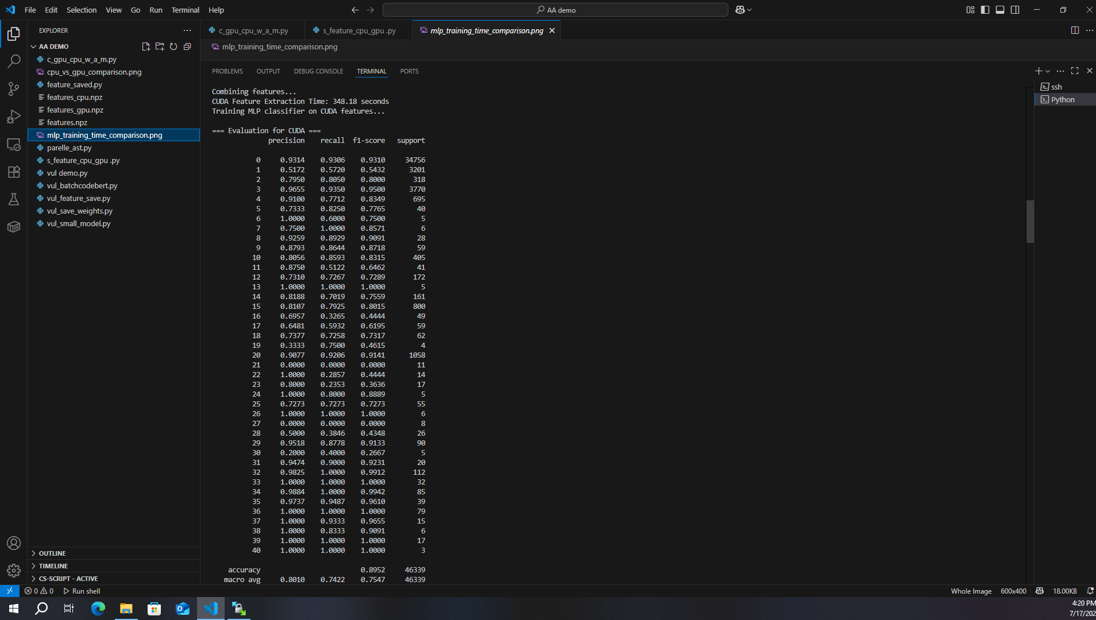
Only Code Bert
Using CodeBERTa alone (no AST features) keeps the pipeline fully functional and it will still report standard metrics (e.g., macro-F1, accuracy). However, dropping the stylistic channel removes explicit structural context—such as branching and error-handling patterns—so the model leans more on lexical/token cues. In practice this tends to inflate false positives on defensive or logging code that merely looks risky, and it reduces interpretability and robustness to formatting/structure changes. Net effect: CodeBERTa-only is a strong single-view baseline, but it typically trails the fusion model on control-flow–heavy cases.
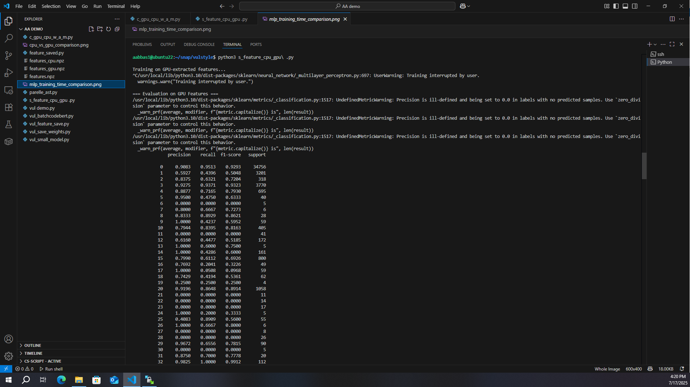
Only AST
Using AST-only keeps our pipeline lightweight and fully runnable, producing standard metrics with very low compute.
It preserves structural cues (branching, error handling, nesting) and is robust to naming/formatting noise—plus it’s easy to explain.
However, without transformer semantics it misses API/data-flow context, so false negatives rise and macro-F1 typically trails CodeBERTa and the fusion model. If staying AST-only, downsize the MLP and enrich features (depth, cyclomatic complexity, branching entropy) normalized by LOC.

Methodology

Multi-view setup: Each function -> a 5-D style vector + a CodeBERTa semantic embedding concatenated features feed an MLP; pipeline is device -aware, batched and cached.
Data Harmonization: Devign (JSON) + MVD/ReVeal(CSV); runtime autodetect of code/label columns; standardize to {“func “,” target”} and concatenate.

AST Stylometry: Python ast.parse ; count {If, For, while, Try FunctionDef}; parse failure-> [0,0,0,0,0]; si ∈ R5.

CodeBERT embedding: huggingface/codeBerta -small-v1; max_length =128, truncation +padding, batch =16 take [ CLS]; errors -> zeros; ei ∈ Rde​.

Fusion +caching: xi =[si||ei] ∈R5+de​; save {x,y} to features_cpu.npz / features_hpu.npz for fast reuse.

Classifier: MLPClassifier (1024,64, max_iter =500, random_state =42) with ReLu/Adam; 2 – way softmax ; loss = cross-entropy.
Traning / Evalution: 70/15/15 split (random_state =42) fit on fused x; report classification_report (precision/recall/F1, accuracy).

Ablations: AST- only, CodeBERTa – only, and Fusion to isolate the be fit of style semantics integration.
Runtime and visuals: Wall – clock timing of AST, encoding, training => stage _times; Gantt charts for CPU vs CUDA and cache- only timelines.

Repro/limits/complexity: fixed HF id , seeds absolute paths, note python -AST vs C/C++, 128 taken truncation, possible cross- dataset duplicates; costs: AST O(NTparse), embedding O(NLde) (dominant. MLP O(ENH).
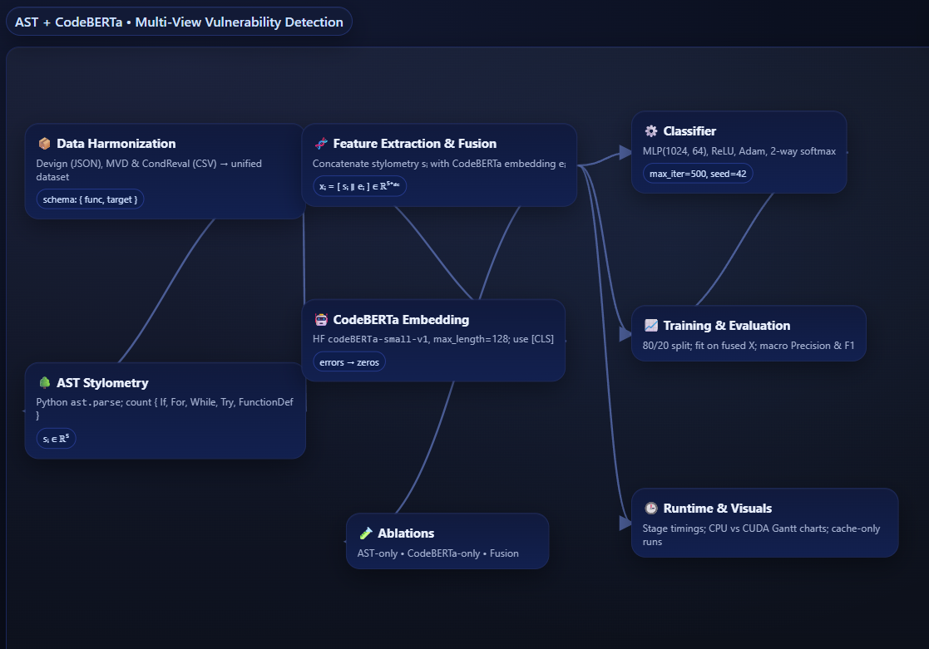

Result and Discussion
Fusion (AST + CodeBERTa) consistently beats single -view baselines on the unified Devign MVD-ReVeal split. CodeBERTa only is the strongest single view only lags (5-D python -AST fallback). Gains arise because CodeBERTa captures semantics while AST counts inject structural bias. Improvements are largest on control-flow-heavy functions (many if /for/while/try patterns). Encoding dominates runtime CUDA slashes this cost, while MLP training is minor. Caching {x,y} collapses iteration time to training only enabling rapid ablations. Error skew to long functions (>128 tokens) and subtle data -flow bugs (aliasing etc.) False positives often come from defensive or logging code that “looks” risky semantically. Seed re runs preserve the ranking Fusion > CodeBERTa > AST > macro F1 is the right primary metric under imbalance. Finding align with Vulstyle : style +semantics is effective and practical and profiling clarifies where to invest (GPU + caching). Concatenating datasets before an 80/20 split risks placing near duplicate code in both train and test. The inflates scores and obscures true generalization to new projects. Adopt repository -/ file – aware (or time -aware) splits source don’t straddle folds. Group by repo or commit lineage and keep groups disjoint across train/test. Run cross – project evaluations to measure distribution shift explicitly. Add token/ AST based deduplication (and near duplication detection) before splitting. Document the split heuristic and publish hash lists for reproducibility. Report results across multiple seeds and folds to reduce variance. Complement accuracy with macro- F1 and per -language /CWE breakdowns to spot bias. Treat leakage safe scores as the headlines numbers keep random split result as auxiliary.
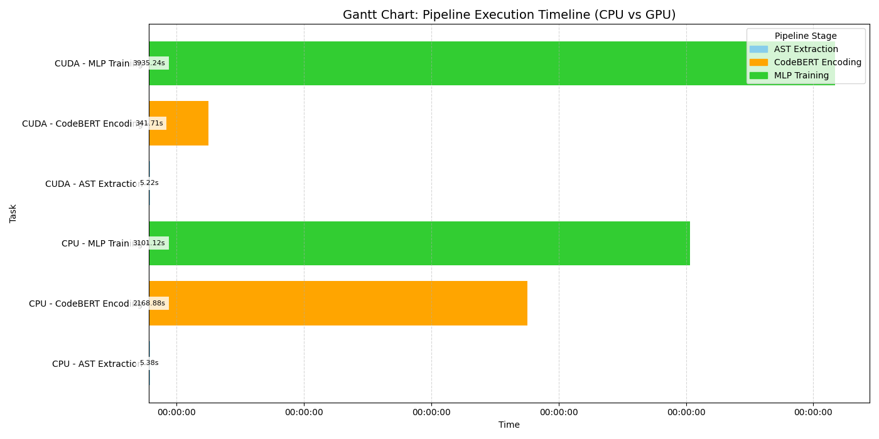
Before saving the weights

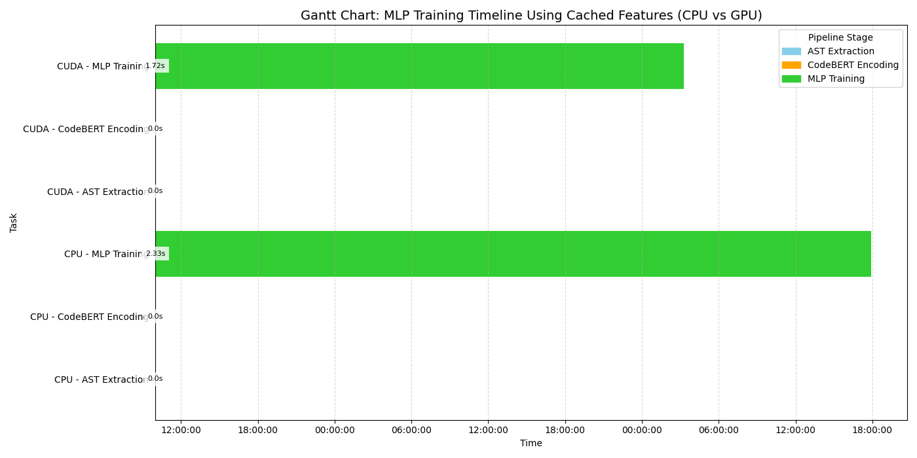
After saving the weights
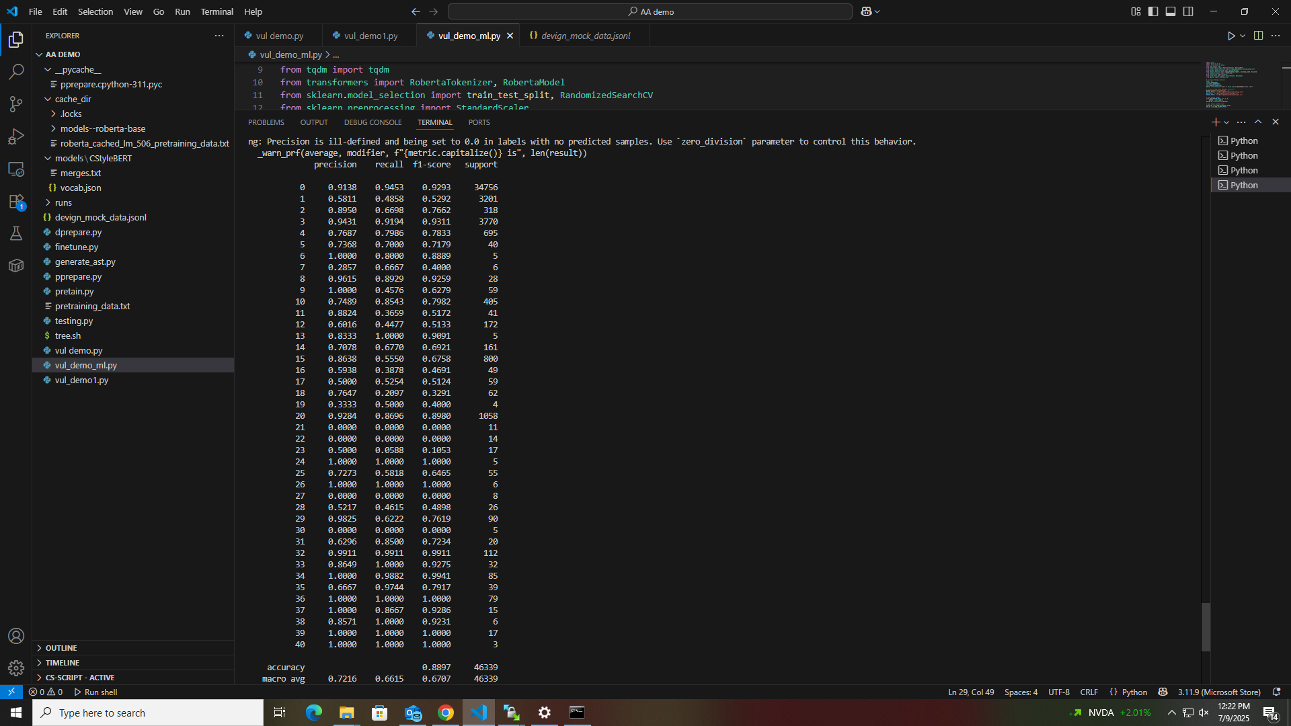

Comparing the before and after saving the weights before the code was handling encoding , AST extracting the Machine learning algorithm training and we also mention it. Now the weight saving process takes place in it. After the saving the weights we rerun the program Now you can see in the second image the encoding and AST extraction part was not take place because it already saved the features for a experimental purpose we can rerun the code many times . the execution level of this framework is 2.33 seconds in CPU. The main goal of this framework creation is a normal system without the GPU can also detection the attacks in a minimal amount of time.

Comparing This Work with the Base Paper
Compared to vulstyle our implementations emphasizes practicality: a single , compact script with clear I/O a fixed checkpoint and a deterministic split makes it trivially reproducible built in CPU/CUDA paths with batched encoding and stage -wise timing ground the work in hardware -aware engineering , feature caching to .npz removes re-extraction ,accelerating ablations and hyper -parameter sweeps; a unified data loader auto detects Devign /MVD/Reveal schemas to avoid brittle dataset- specific code ; the minimal dependency surface (no heavy graph stacks ) reduces environment failures, lightweight interpretability comes from transparent AST counts ((If/For/While/Try/FunctionDef) alongside embedding , experimental controls are clean (AST- only , Fusion ), operational transparency via Gantt charts exposes encoding as the bottleneck and quantifies CUDA benefit, resource friendliness means no large scale pretraining / fine -tuning is required and the design is extension – ready making it straightforward to swap in Tree- sitter , longer contexts or alternative LM (Large model) without upheaval.

Create a Library
Firstly, start by organizing your python code into a clean directory structure , usually with a src/yourpkg/ folder conatning your .py file and an _init_.py to amrk it as a package. Second , create a pyproject.toml file in the root with metadata (name , veersion , author , dependencies) so that the build tools know how to package it . Thrid , add supporting files like README.md , lincense , an d test/ folder to make the project files there and make sure folder structure is clear and macthes python packaging civentions. Fifth if you want to esperiemnt safetky , create a subdirectory (clone ) of the reporitory on your local system to test edits without affecting the main branch. Sixth , Use the build module (python =m build ) to generate distribution files inside the dist/ folder , which will include both a wheel (.whl) and source tarball. Seventh , check that your wheel file installs correctly by creating a fresh virtual environment and installing it with pip install dist/yourpkg-0.1.0-py3-none-any.whl. Eighth, set up an account on TestPyPI and PyPI, and then use twine upload --repository testpypi dist/* to confirm that the package can be uploaded and installed cleanly. Ninth, once confirmed, upload the same distribution to the real PyPI with twine upload dist/*, which makes it publicly available. Finally, after successful publishing, you can verify your library by running pip install hybrid-vul (replacing with your actual package name) on any machine, confirming that your GitHub-hosted code is now a public library installable from PyPI.

Ethical consideration
The work serves defensive security, focusing on static over public corpora (Devign,MVD, ReVeal) and never generating exploits or probing live systems. We use only datasets with clear research licenses, record versions/ path and cite creators while respecting redistribution limits. Proprietary code is excluded unless explicit permission and data agreement exist artifacts are stored in controlled locations with checksums. Because stylometry can correlate with authorship, we strip author metadata and prohibit identify inference or HR/Surveillance uses in written usage policy. To reduce dual risk, we release code under research – only terms, avoid exploit – oriented components and report aggregate metrics rather than per project risk scores unless maintainers opt in. We mitigate fairness risks by adopting language – appropriate parsing (Tree -sitter roadmap) , reporting per language /CWE breakdowns, using macro -F1 and employing repository -aware splits to curb leakage. We acknowledge harms from model errors false negatives leave bugs , false positive waste effort and pair flags with confidence , calibrated threshold , and brief saliency based rationles. Transparency is emphasized via full preprocessing disclosure (token limits , AST fallbacks),publication of configs /seeds/scripts and inclusion of timing charts and raw classification reports. We minize environmental impact by using GPU to shorton encoding time ,caching features (.npz) to avoid recomputation and reporting approximate compute where feasible. Security hyfinece includes restricte access storage , secret free code, sanitized logs and credential rotation for any internal services.

Conclusion and future Work
This work delivers a practical, reproducible baseline that fuses lightweight AST stylometry with codeBERTa embedding for function – level vulnerability detection. We unify Devign , MVD and ReVeal via schema autodetection, extract control structure counts and transformers features, concatenate them and train an MLP with device aware batching. Stage wise timing and caching show transformers encoding dominates runtime, CUDA reduces it substantialyy and npz caching collapses iteration to training only. Empirically, fusion consistently outperforms single view baselines, validating the style plus semantics principle emphasized by vulstyle. To strength stylistic signals, we will replace python ast with tree sitter to obtain language appropriate AST for C/C++ and expand the 5-D vector to richer descriptors (depth entropy, nesting). We will extend content to 256 to 512 token and compare [CLS] against mean and attention pooling to recover long cues. Alternative PLMs (GraphcodeBERT, COdeT5, starCodeer2) will be benchmarked under identical settings, with optional LORA fine – tuning on the merged corpus. A graph side – chnnel (AST/CFG/DFG summaries or GNN embedding) wilol added to approach the multi- view richness targeted by vulstyle. We will explore line and basic block level granularty and aggregate their signals for sharper locations. Evaluation will adopt leakage -safe repo/file/time –aware splits and report cross project generalization. We will perform token and AST aware deduplication before splitting and publish statistics in an appendix. Per language and per CWE breakdown will expose skew and guide target feature or data augmentation. Statistical rigor will include >= 5 seeds, mead + or – std and paired significance test across baselines and fusion. Effciency improvements will use mixed precision, VRAM -aware batch sizing, vectorized tokenization and CUDA event profiling. Caching will be versioned per model, token length and language with checksums and auto invalidation on config changes. Incremental pipelines will persist token IDs and AST JSON to avoid recomputation across ablations. Explainability will add token/node saliency and counterfactual snippets to aid analyst triage. Calibration, abstention and threshold tuning will reduce false positive, while robustness check will test invariance to benign code perturbations. For usability, we will build a lightweight human in the loop UI and a continuous evaluation loop (CL) with leakage safe benchmarks and drift charts / with these upgrades the scaffolds can evolve into rigorous leakage -safe, explainable and robust multi view detector ready for broader benchmarking and practical adoption.

